1. Explain the heap property of a tree

2. List and describe the 3 methods most often associated with a stack.

3. Identify 3 errors in the following code snippet:

num = input()

def factorial[n]:

if n == 0:

return 1;

else:

return n * factorial(n-1)

num(factorial)

4. Suppose there are 2 circles on a cartesian plane at (1,1) and (4,1), with a radius of m and n respectively. Write psuedocode that determines if the two circles overlap.

5. Use pseudocode to design a class that represents a car.

6. Explain the meaning and use of the global keyword in python

7. Draw a binary search tree containing the items added in order of [14, 5, 21, 3, 7, 8, 9, 1, 12]:

8. Give the Big-O performance of the following code fragment:

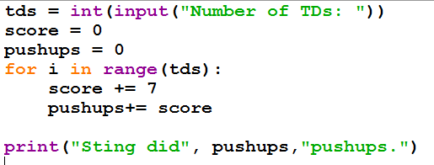

9.Give the Big-O runtime of the following code snippet:

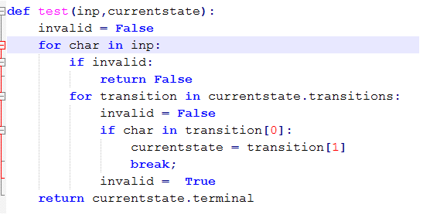

10. Write a python program that uses **a dictionary** to store the following states and capitals.

Des Moines, Iowa  
Jefferson City, Missouri  
Albany, New York  
Sacramento, California  
Austin, Texas  
Lincoln, Nebraska

Finally, print the capital of california from your dictionary.  
  
stateCapitals = {}

def addStates(num):

   #your solution here

print()  # modify this line as well

11.Define the following terms in the context of computer science:

a. Complexity

b. Heuristic

c. Linear

d. Tree

e. Stack

f. Node

g. Graph

h. Queue

i. Quadratic

j. Exception

k. Dictionary